**HMS Animal Model Data Requirements**

The HMS AQUATOX animal model consists of one new JSON object

* **TAnimal**:

To calculate changes in animal biomass, the following other state variables or driving variables (i.e. modeled using observed data or linkage from other HMS components) must be included in the HMS AQUATOX JSON.

* TBA
* Plants are not technically required, but

If [] are not explicitly modeled within HMS AQUATOX, a user may still wish to model the impact of [] on animal biomasses in the model. Time-series (or constant) linkages from other models (or user estimates) may be input into the model directly within the JSON files as summarized here (all units are g/m3⋅d):

|  |  |  |  |
| --- | --- | --- | --- |
| **State Variable** | **Derivative Linkage** | **Name within JSON** | **Omit if explicitly modeling** |
| TPlant | *Predation* | "Predation_Link" | Animals |
| TMacrophyte | *Predation* | "Predation_Link " | Animals |

Example JSON data files for an AQUATOX animal model may be found in the associated DOCS directory. For a summary of general HMS AQUATOX JSON characteristics please see the document “AQUATOX_JSON_Structure” within the Data.Simulate.AQUATOX/DOCS folder.

The many biological characteristics governing aquatic animals make for a relatively complicated set of derivatives. The following pages are excerpts from the relevant sections of the AQUATOX Release 3.2 Technical Documentation. The HMS animal model was not changed from the AQUATOX Release 3.2 implementation and model results were carefully verified against AQUATOX Release 3.2 results.

**4. BIOTA**

The biota consists of two main groups, plants and animals; each is represented by a set of process-level equations.

**Biota: Simplifying Assumptions**

* Biomass is simulated but not numbers of individual organisms
* Responses are simulated as averages for the entire group

Animals are subdivided into invertebrates and fish; the invertebrates may be “plankton invertebrates,” “nekton invertebrates,” “benthic insects,” or other “benthic invertebrates.” These groups are represented by different parameter values and by variations in the equations. Insects are subject to emergence and therefore are lost from the system, but benthic invertebrates are not. Fish may be represented by both juveniles and adults, which are connected by promotion. One fish species can be designated as multi-year with up to 15 age classes connected by promotion. Differences are shown in Table 6.

**Table 6.** Significant Differentiating Processes for Animals

|  |  |  |  |  |  |  |
| --- | --- | --- | --- | --- | --- | --- |
| **Animal Type** | **Washout** | **Drift** | **Scour Entrainment** | **Emergence** | **Promotion/ Recruitment** | **Multi-year** |
| Plankton Invert. | ❑ |  |  |  |  |  |
| Nekton Invert. |  | ❑ | ❑ |  | * |  |
| Benthic Invert. |  | ❑ | ❑ |  | * |  |
| Benthic Insect |  | ❑ | ❑ | ❑ |  |  |
| Fish |  |  | ❑ |  | ❑ | ❑ |

* Oysters or size-class predatory invertebrates.

**Anti-Extinction Code**

Plants or animals with non-zero initial conditions are assumed to be “seeded” in the case that their biomass drops to zero. This allows for species recovery in the aftermath of a physical or chemical shock to a system. Each time a plant or animal has a biomass that falls to below 1x10-10 mg/L that organism is re-seeded with a loading of 1x10-7 mg/L.

**Guild Organization**

To better generalize the aquatic ecosystem and to represent marine-biology conventions, the guilds used by AQUATOX to characterize animals have been reorganized in this version. Specifically, “shredders” have been renamed to “deposit feeders” and the “grazer” compartment has been split into “suspended feeders” and “deposit feeders.” The animal compartments available for food web modeling are as follows:

|  |  |
| --- | --- |
| **Guild Name** | **Number of Compartments** |
| Suspension Feeders | 6 |
| Deposit Feeders | 3 |
| Veliger | 2 |
| Spat | 2 |
| Clams/Adult Oysters | 4 |
| Snails | 2 |
| Small Predatory Invert. | 2 |
| Predatory Invertebrate | 4 |
| Small Forage Fish | 2 |
| Large Forage Fish | 2 |
| Small Bottom Fish | 2 |
| Large Bottom Fish | 2 |
| Small Game Fish | 4 |
| Large Game Fish | 4 |
| Age-Class Fish | 15 |

**4.3 Animals**

**Animals: Simplifying Assumptions**

* Ingestion is represented by a maximum consumption rate adjusted for conditions of food, temperature, sublethal toxicant effects, and habitat preferences
* Reproduction is implicit in the increase in biomass
* Macrophytes can provide refuge from predation
* AQUATOX is a food-web model including prey switching based on prey availability
* Specific dynamic action (the metabolic “cost” of digesting and assimilating prey) is represented as proportional to food assimilated
* Unless spawning dates are entered by the user, spawning occurs as a function of water temperature
* Zooplankton and fish will migrate vertically from an anoxic hypolimnion to the epilimnion
* Promotion from one size class of fish to the next is estimated as a fraction of total biomass growth

Zooplankton, benthic invertebrates, benthic insects, and fish are modeled, with only slight differences in formulations, with a generalized animal submodel that is parameterized to represent different groups:

 **(90)**

where:

*dBiomass/dt* = change in biomass of animal with respect to time (g/m3⋅d);

*Load* = biomass loading, usually from upstream, or calculated from user-supplied fish stocking data (g/m3⋅d);

*Consumption* = consumption of food (g/m3⋅d), see **(98)**;

*Defecation* = defecation of unassimilated food (g/m3⋅d), see **(97)**;

*Respiration* = respiration (g/m3⋅d), see **(100)**;

*Fishing* = loss of organism due to fishing pressure (g/m3⋅d), user input fraction fished multiplied by the biomass.

*Excretion* = excretion (g/m3⋅d), see **(111)**;

*Mortality* = nonpredatory mortality (g/m3⋅d), see **(112)**;

*Predation* = mortality from being preyed upon (g/m3⋅d), see **(99)**;

*GameteLoss* = loss of gametes during spawning (g/m3⋅d), see **(126)**;

*Washout* = loss due to being carried downstream by washout and drift (g/m3⋅d), see **(129)** and **(130)**;

*Washin*  = loadings from linked upstream segments (g/m3·d), see **(30)**;

*DiffusionSeg* = gain or loss due to diffusive transport over the feedback link between two segments, pelagic inverts. only (g/m3⋅d), see **(32)**;

*Migration* = loss (or gain) due to vertical migration (g/m3⋅d), see **(133)**;

*Promotion* = promotion to next size class or emergence (g/m3⋅d), see **(136)**;

*Recruit* = recruitment from previous size class (g/m3⋅d), see **(128)**;

*Entrainment* = entrainment and downstream transport by floodwaters (g/m3⋅d) **(132).**

*GrowthRate* = estimated growth rate as a function of derivative terms, output in units of percentage per day when animal’s “rates output” is turned on.

The change in biomass (Figure 70) is a function of a number of processes (Figure 71) that are subject to environmental factors, including biotic interactions. Similar to the way algae are treated, parameters for different species of invertebrates and fish are loaded and available for editing by means of the entry screens. Biomass of zoobenthos and fish is expressed as g/m2 instead of g/m3.

Growth rates have been part of AQUATOX output since Release 3.0. However, this output has always been reported in units of “percent (of current biomass) per day.” To better understand total predicted secondary and tertiary productivity, and to effectively compare model results against literature estimates, as of Release 3.2 growth rates are also output in “g AFDW/ m2∙day.”

Figure . Predicted changes in biomass in a stream



Figure . Predicted Process Rates for the Invasive Clam *Corbicula*, Expressed as Percent of Biomass; Yellow Spikes are Entrainment During Storm Events; Consumption Depends on Sloughing Periphyton..



**Consumption, Defecation, Predation****, and Fishing**

Several formulations have been used in various models to represent consumption of prey, reflecting the fact that there are different modes of feeding and that experimental evidence can be fit by any one of several equations (Mullin et al., 1975; Scavia, 1979; Straškraba and Gnauck, 1985).

Ingestion is represented in AQUATOX by a maximum consumption rate, adjusted for ambient food, temperature, oxygen, sediment, and salinity conditions, and reduced for sublethal toxicant effects and limitations due to habitat preferences of a given predator:

 **(91)**

where:

*Ingestionprey, pred* = ingestion of given prey by given predator (g/m3⋅d);

*Biomass* = concentration of organism (g/m3⋅d);

*CMax* = maximum feeding rate for predator (g/g⋅d);

*SatFeeding* = saturation-feeding kinetic factor, see **(93)**;

*TCorr* = reduction factor for suboptimal temperature (unitless), see Figure 59;

*FoodDilution* = factor to account for dilution of available food by suspended sediment (unitless), see **(120)**;

*ToxReduction* = reduction due to effects of toxicant (see **(424)**, unitless); and

*HarmSS* = reduction due to suspended sediment effects (see **(116)**, unitless);

*SaltEffect* = effect of salinity on ingestion rate (unitless), see **(440)**;

*O2EffectFrac* = effect ofreduced oxygen on ingestion (unitless), see **(205);** and

*HabitatLimit* = in streams, habitat limitation based on predator habitat preferences (unitless), see **(13)**.

The maximum consumption rate is sensitive to body size, so an alternative to specifying *CMax* for fish is to compute it using an allometric equation and parameters from the Wisconsin Bioenergetics Model (Hewett and Johnson, 1992; Hanson et al., 1997):

 **(92)**

where:

*CA* = maximum consumption for a 1-g fish at optimal temperature (g/g⋅d);

*MeanWeight* = mean weight for a given fish species (g);

*CB* = slope of the allometric function for a given fish species.

Many animals adjust their search or filtration in accordance with the concentration of prey; therefore, a saturation-kinetic term is used (Park et al., 1974, 1980; Scavia and Park, 1976):

 **(93)**

where:

*Preference* = preference of predator for prey (unitless);

*Food* = available biomass of given prey (g/m3);

*FHalfSat* = half-saturation constant for feeding by a predator (g/m3).

The food actually available to a predator may be reduced in two ways:

 **(94)**

where:

*BMin* = minimum prey biomass needed to begin feeding (g/m3); and

*RefugeMacro* = reduction factor for prey hiding in macrophytes or seagrass (unitless), see **(95)**;

*RefugeOyster* = reduction factor for prey hiding among oysters (unitless), see **(95)**;

*RefugeMarsh* = reduction factor for prey hiding in marsh edge; may also enhance predation if marsh is disintegrating (unitless), see **(95b)**;

*RefugeBurrow* = reduction factor for prey’s capability to burrow into sediment, characterized by “*BurrowIndex*” parameter (unitless), see **(95c)**.

Search or filtration may virtually cease below a minimum prey biomass (*BMin*) to conserve energy (Figure 72), so that a minimum food level is incorporated (Parsons et al., 1969; Steele, 1974; Park et al., 1974; Scavia and Park, 1976; Scavia et al., 1976; Steele and Mullin, 1977). However, some filter feeders such as cladocerans (for example, *Daphnia*) must constantly filter because the filtratory appendages also serve for respiration; therefore, in these animals there is no minimum feeding level and *BMin* is set to 0.

Figure . Saturation-kinetic consumption

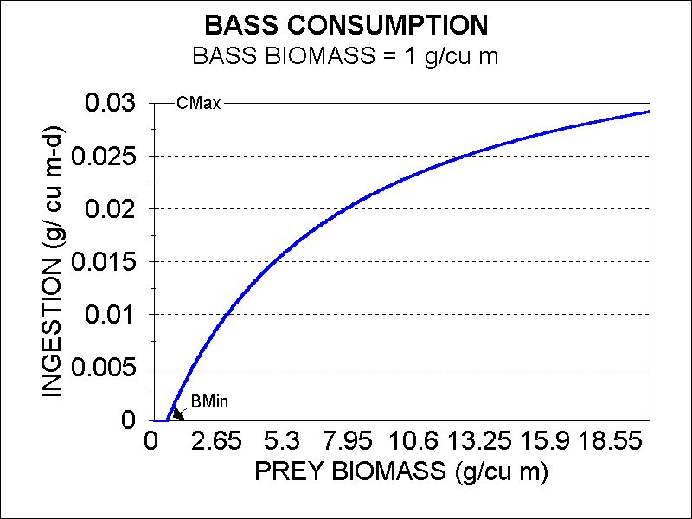

**Refuge from Predation**

Although AQUATOX is an ecosystem biomass model, it has some capability to represent habitat characteristics. In particular, the model can account for the function of macrophytes or seagrass as a habitat structure that provides refuge from predation. This refuge is represented by a factor related to the macrophyte biomass that is original with AQUATOX (Figure 73):

 **(95)**

where:

*HalfSat* = half-saturation constant (20 g/m3),

*BiomassMacro* = biomass of macrophyte (g/m3), or

*BiomassOyster* = biomass of oyster (g/m3).

Figure . Refuge from predation

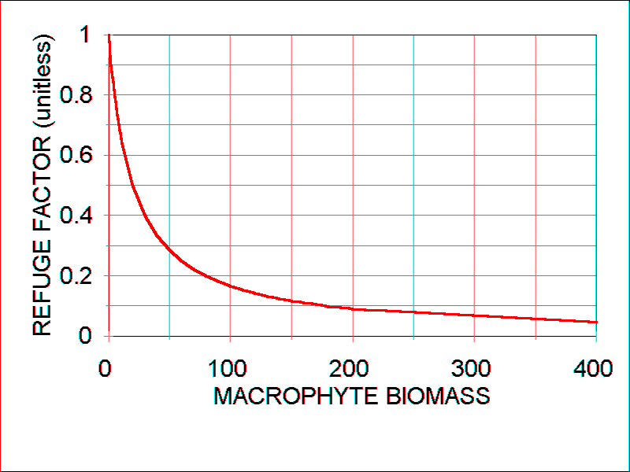

Similarly, oyster beds provide structural refuge whereby smaller animals may hide in crevices and dead shells. Using the same equation **(95)**, but based on biomass of oysters with a nominal *HalfSat* value of 80 g/m3, we get a slightly different form of reduction in the predator-prey relationship (Figure 74). The parameter may be fine-tuned based on published studies (Lenihan 1999, Grabowski and Powers 2004).

A boolean parameter “*Can Seek Refuge*” in the animal underlying data specifies whether an animal can seek refuge within macrophytes or oyster beds. Many fish and invertebrates can, but not infauna. Similarly, a boolean parameter “*Is a Visual Feeder*” in the animal underlying data specifies whether an animal’s prey can effectively seek refuge.

Figure . Refuge from predation

**Fractal Dimension of Marsh Edge**

Another type of refuge is provided by tidal creeks and the diffuse interface between marsh and water. The irregularity of the saltmarsh-water interface as a refuge capacity can be represented as a fractal dimension. This construct was originally developed for the Sea Level Affecting Marshes Model (SLAMM) (Park et al. 1989) and was approved by a peer review panel in 1990 (http://www2.epa.gov/exposure-assessment-models/peer-review-aquatox). Parameter values for brown and white shrimp were based on catch statistics provided by the National Marine Fisheries Service Galveston Lab (see also Zimmerman et al. 1991) and results were reported in Congressional testimony by Park (1991).

If the shoreline-marsh interface were a straight line it would have a fractal dimension of 1.0, corresponding to the Euclidean integer dimension; this is characteristic of coastlines subjected to erosional retreat. Healthy marshes have a fractal dimension in excess of 1.0 (intermediate between the Euclidean dimensions of a line and a surface). Examples of marsh areas with calculated fractal dimensions are taken from Grand Bay on the border between Mississippi and Alabama (Figure 75). With inundation due to a relative rise in sea level, as the interface becomes more irregular due to disintegration of the marsh, the fractal dimension becomes larger. Eventually, the marsh may break up into scattered remnants with a fractal dimension < 1.0 (intermediate between the Euclidean dimensions for a line and a point). These relationships, with the concomitant increase in refuge and even the loss of refuge, can be represented by a slightly different equation.

 **(95b)**

where:

*FractalDMarsh* = fractal dimension of marsh-water interface;

*Coeff* = fractal dimension Refuge coefficient (-0.5 to 100 with the lowest values providing the strongest Refuge effect).



Coefficient of -0.15

Figure . Refuge Factor as a Function of Marsh-Edge Fractal Dimension

The fractal dimension is computed based on the co-occurrence of marsh and water in the same GIS cells. Figure 75 shows three examples of computed fractal dimensions.

Figure . Examples of marsh areas with calculated fractal dimensions from Grand Bay, MS

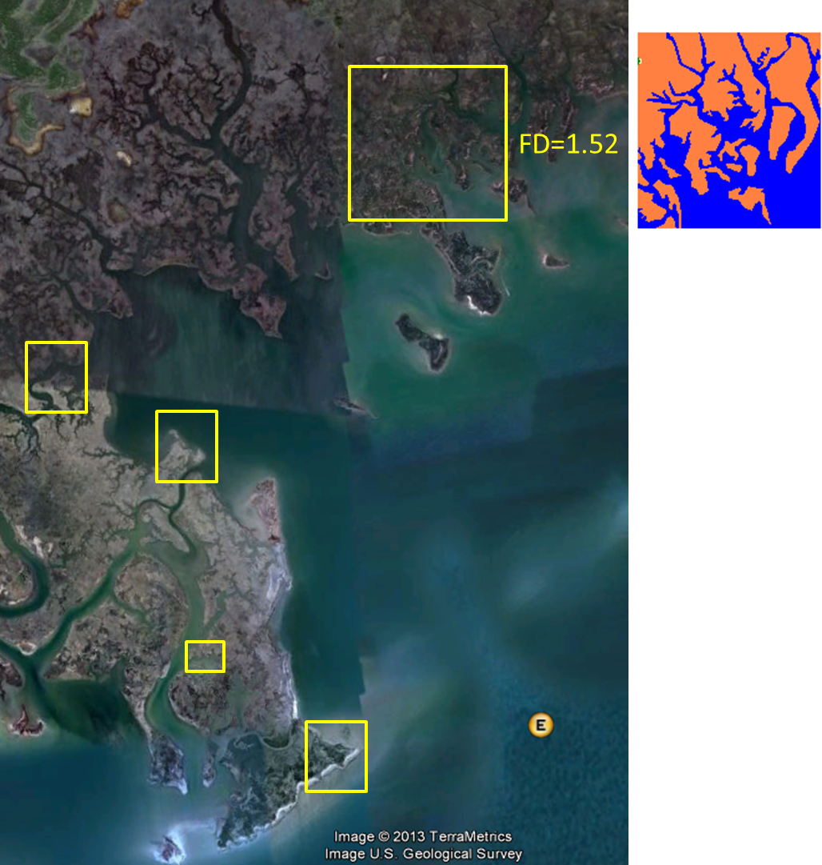

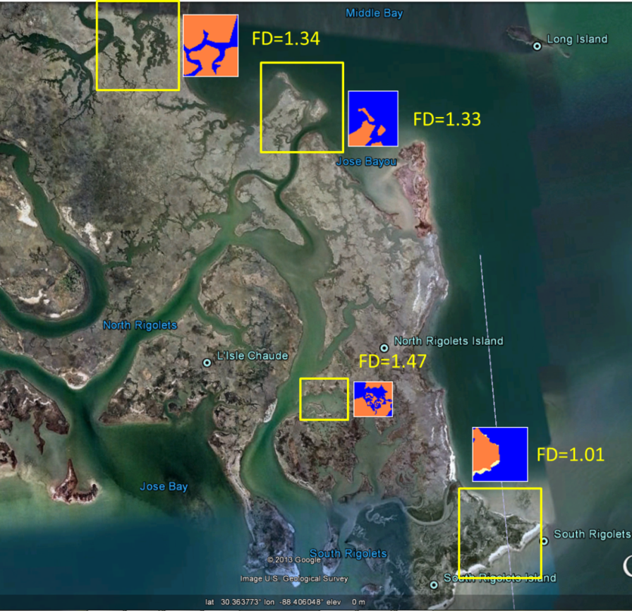

### 

**Burrowing Refuge for Invertebrates**

Many marine benthic invertebrates have the capability to elude predators due to burrowing. To ensure that organisms with deep burrows are not subject to excess predation a burrowing refuge construct has been added to AQUATOX.

 **(95c)**

where:

*RefugeBurrow =* unitless multiplier to represent burrowing refuge, see **(95);**

*BurrowIndex =* animal-specific parameter (unitless) with 0 representing no burrowing refuge;

*HalfSatBurrow =* half saturation coefficient for burrowing (unitless), set to 3.2.

The *BurrowIndex* parameter may be calibrated on an animal-specific basis to best represent the extent of burrowing that reduces predation pressure on an organism (Figure 2). Some example starting points for calibration are listed below:

* Blue Crab (*Callinectes*) is a limited burrower so it would have a *BurrowIndex* of 0.5;
* Sand Crab (*Emerita*) creates shallow burrows so it would have a *BurrowIndex* of 1.0;
* *Donax* may be assumed to have more burrowing refuge than *Emerita* so it would have a *BurrowIndex* of 2.0;
* Ghost Shrimp (*Callichirus*) are deep burrowers so they would have the maximum *BurrowIndex* of 5.0.

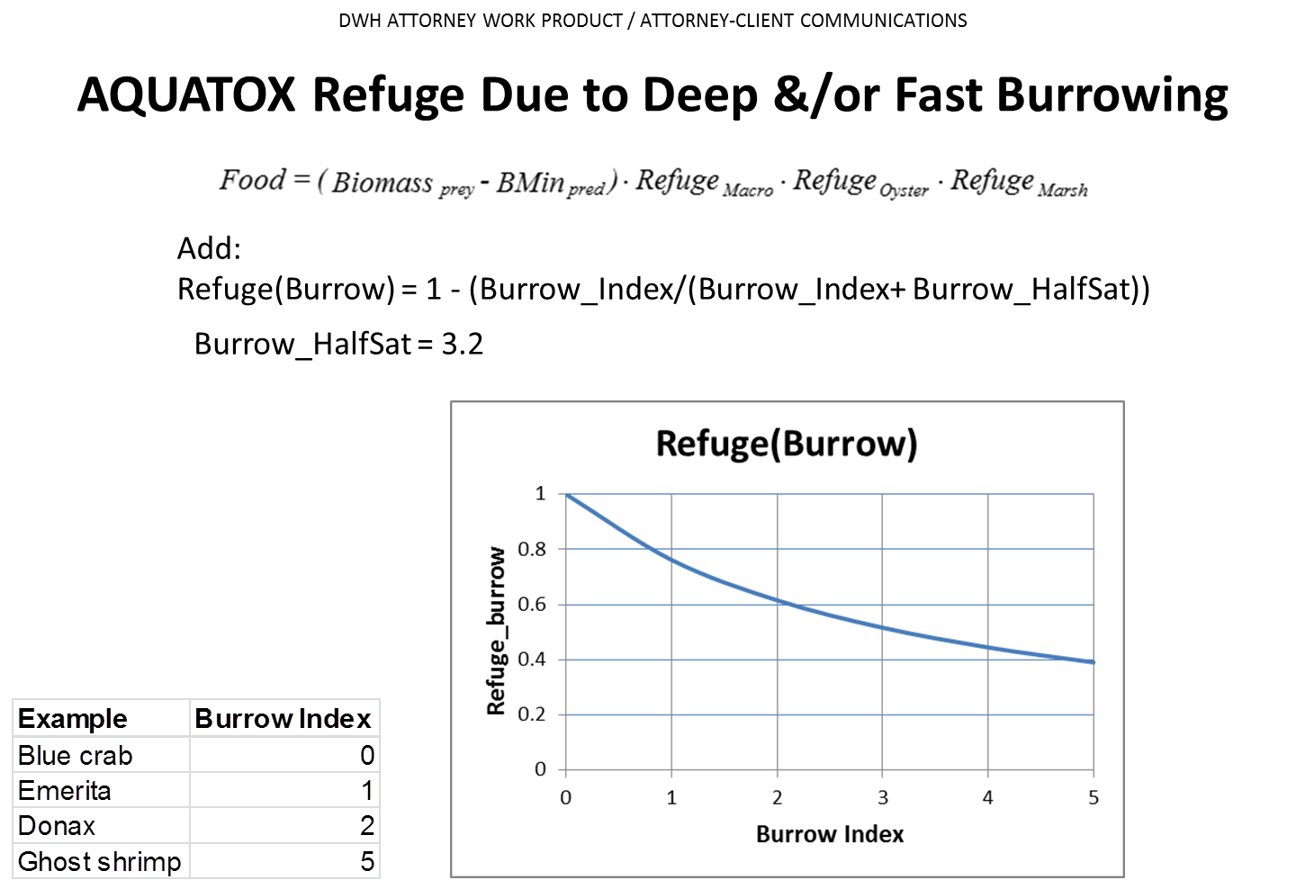

Figure . Relationship between “*Burrow Index*” Parameter and Calculated “*Refuge*”

**Adaptive Food Preferences**

AQUATOX is a food-web model with multiple potential food sources. Passive size-selective filtering (Mullin, 1963; Lam and Frost, 1976) and active raptorial selection (Burns, 1969; Berman and Richman, 1974; Bogdan and McNaught, 1975; Brandl and Fernando, 1975) occur among aquatic organisms. Relative preferences are represented in AQUATOX by a matrix of preference parameters first proposed by O'Neill (1969) and used in several aquatic models (Bloomfield et al., 1973; Park et al., 1974; Canale et al., 1976; Scavia et al., 1976). Higher values indicate increased preference by a given predator for a particular prey compared to the preferences for all possible prey. In other words, the availability of the prey is weighted by the preference factor.

The preference factors are normalized so that if a potential food source is not modeled or is below the *BMin* value, the other preference factors are modified accordingly, representing adaptive preferences:

 **(96)**

where:

*Preferenceprey,pred* = normalized preference of given predator for given prey (unitless);

*Prefprey, pred* = initial preference value from the animal parameter screen (unitless); and

*SumPref* = sum of preference values for all food sources that are present above the minimum biomass level for feeding during a particular time step (unitless).

Similarly, different prey types have different potentials for assimilation by different predators. The fraction of ingested prey that is egested as feces or discarded (and which is treated as a source of detritus by the model, see **(153)** and **(154)**), is indicated by a matrix of egestion coefficients with the same structure as the preference matrix, so that defecation is computed as (Park et al., 1974):

 **(97)**

where:

*Defecationpred* = total defecation for given predator (g/m3⋅d);

*Ingestionprey, pred* = ingestion of given prey by given predator (g/m3⋅d) **(91)**;

*EgestCoeff*prey, pred = fraction of ingested prey that is egested (unitless); and

*IncrEgest* = increased egestion due to toxicant (see Eq. **(425)**, unitless);

*IngestNoTox* = ingestion excluding toxic effects, calculated as *Ingestion* divided by *ToxReduction* (see Eq. **(424)**, g/m3⋅d).

Consumption of prey for a predator is also considered predation or grazing for the prey. Therefore, AQUATOX represents consumption as a source term for the predator and as a loss term for the prey:

 **(98)**

 **(99)**

where

*Consumption*pred = total consumption rate by predator (g/m3⋅d); and

*Predation*prey = total predation on given prey (g/m3⋅d).

Fishing pressure is represented simply as a fraction of biomass removed each day. A potential future model enhancement could allow for temporally variable fishing pressures to better reflect harvesting seasons. Fish may also be stocked within a modeled system by entering time series in grams per day or grams per meter squared per day.

**Respiration**

Respiration can be considered as having three components (Cui and Xie, 2000), subject to the effects of salinity:

 **(100)**

where:

*Respirationpred* = respiratory loss of given predator (g/m3⋅d);

*StdResppred* = basal respiratory loss modified by temperature (g/m3⋅d); see **(101)**;

*ActiveResppred* = respiratory loss associated with swimming (g/m3⋅d), see **(104)**;

*SpecDynAction*pred = metabolic cost of processing food (g/m3⋅d), see **(110)**; and

*SaltEffect* = effect of salinity on respiration (unitless), see **(440)**.

Standard respiration is a rate at resting in which the organism is expending energy without consumption. Active respiration is modeled only in fish and only when allometric (weight-dependent) equations are used, so standard respiration can be considered as a composite “routine” respiration for invertebrates and in the simpler implementation for fish. The so-called specific dynamic action is the metabolic cost of digesting and assimilating prey. AQUATOX simulates standard respiration as a basal rate modified by a temperature dependence and, in fish, a density dependence (see Kitchell et al., 1974):

 **(101)**

where:

*BasalResp*pred = basal respiration rate at optimal temperature for given predator (g/g⋅d); parameter input by user as “Respiration Rate” or computed as a function of the weight of the animal (see below);

*TCorrpred* = Stroganov temperature function (unitless), see Figure 59;

*Biomasspred* = concentration of predator (g/m3); and

*DensityDep* = density-dependent respiration factor used in computing standard respiration, applicable only to fish (unitless). See **(109)**

As an alternative formulation, respiration in fish or invertebrates can be modeled as a function of the weight of the fish using an allometric equation (Hewett and Johnson, 1992; Hanson et al., 1997):

 **(102)**

where:

*MeanWeightpred* = mean weight for a given fish (g);

*RBpred* = slope of the allometric function for a given fish;

*TFn*pred = temperature function (unitless).

The allometric functions are based on the well known Wisconsin Bioenergetics Model and, for convenience, use the published parameter values for that model (Hewett and Johnson, 1992; Hanson et al., 1997). Weight-based bioenergetic functions have been extended to invertebrates by several authors (for example, Brylawski and Miller 2003, Adamack et al. 2012) and that capability is available as an enhancement in the present version of AQUATOX.

The basal respiration rate in that model is expressed as g of oxygen per g organic matter of fish per day, and this has to be converted to organic matter respired:

 **(103)**

where:

*RApred* = basal respiration rate, characterized as the intercept of the allometric mass function in the Wisconsin Bioenergetics Model documentation (g O2/g organic matter ⋅d);

1.5 = conversion factor (g organic matter/g O2).

Swimming activity may be large and variable (Hanson et al., 1997) and is subject to calibration for a particular site, considering currents and other factors:

 **(104)**

where:

*Activitypred* = activity factor (g/g⋅d).

Activity can be a complex function of temperature. The Wisconsin Bioenergetics Model (Hewett and Johnson, 1992; Hanson et al., 1997) provides two alternatives. **Equation Set 1** uses an exponential temperature function:

 **(105)**

where:

*RQ* = the Q10 or rate of change per 10deg. C for respiration (1/deg. C);

*Temp* = ambient temperature (deg. C).

This is coupled with a complex function for swimming speed as an allometric function of temperature (Hewett and Johnson, 1992; Hanson et al., 1997):

 **(106)**

where:

*RTO* = coefficient for swimming speed dependence on metabolism (s/cm);

*RTL* = temperature below which swimming activity is an exponential function of temperature (deg. C);

*Vel* = swimming velocity (cm/s);

*RK1* = intercept for swimming speed above the threshold temperature (cm/s);

*RK4 =* weight-dependent coefficient for swimming speed;

*ACT* = intercept for swimming speed for a 1 g fish at deg. C (cm/s); and

*BACT* = coefficient for swimming at low temperatures (1/deg. C),

**Equation Set 2** uses the Stroganov function used elsewhere in AQUATOX:

 **(107)**

and activity is a constant:

 **(108)**

where:

*TCorr* = reduction factor for suboptimal temperature (unitless), see **(59)**;

*ACT* = activity factor, which is not the same as *ACT* in Equation Set 1 (g/g⋅d).

Respiration in fish increases with crowding due to competition for spawning sites, interference in feeding, and other factors. This adverse intraspecific interaction helps to constrain the population to the carrying capacity; as the biomass approaches the carrying capacity for a given species the respiration is increased proportionately (Kitchell et al., 1974):

 **(109)**

where:

*IncrResp* = increase in respiration at carrying capacity (0.5);

*KCap* = carrying capacity (g/m2);

*ZMean* = mean depth from site underyling data (m).

With the *IncrResp* value of 0.5, respiration is increased by 50% at carrying capacity (Kitchell et al., 1974), as shown in Figure 76. This density-dependence is used only for fish, and not for invertebrates.

Prior to AQUATOX Release 3.2, the benthic invertebrate “carrying capacity” parameter has had little impact on simulations. With some marine-benthic invertebrate species, (oysters, for example) available substrate becomes a limiting factor. For this reason, the model now enforces a hard-cap at the benthic invertebrate carrying capacity by increasing mortality if the biomass exceeds that level:

 **(109b)**

where:

*MortKCap* = mortality of zoobenthos due to exceeding available substrate (g/m2);

*BiomassBenthos =* biomass of zoobenthos (g/m2); and

*KCapBenthos =* user input carrying capacity for this site and zoobenthos species (g/m2).

Figure . Density-dependent factor for increase in respiration as fish

biomass approaches the carrying capacity (10.0 in this example).



As a simplification, specific dynamic action is represented as proportional to food assimilated (Hewett and Johnson, 1992; see also Kitchell et al., 1974; Park et al., 1974):

 **(110)**

where:

*KResppred* = proportion of assimilated energy lost to specific dynamic action (unitless); parameter input by user as “Specific Dynamic Action;”

*Consumption*pred = ingestion (g/m3⋅d) see **(98)**; and

*Defecation*pred = egestion of unassimilated food (g/m3⋅d), see **(97)**.

**Excretion**

As respiration occurs, biomass is lost and nitrogen and phosphorus are excreted directly to the water (Horne and Goldman 1994); see **(169)** and **(183)**. Ganf and Blazka (1974) have reported that this process is important to the dynamics of the Lake George, Uganda, ecosystem. Their data were converted by Scavia and Park (1976) to obtain a proportionality constant relating excretion to respiration:

 **(111)**

where:

*Excretionpred* = excretion rate (g/m3⋅d);

*KExcrpred* = proportionality constant for excretion:respiration (unitless);

*Respirationpred* = respiration rate (g/m3⋅d), see **(100)**.

Excretion is approximately 17 percent of respiration, which is not an important biomass loss term for animals, but it is important in nutrient recycling. All biomass lost due to animal excretion is assumed to convert to dissolved labile detritus, see **(151)**.

**Nonpredatory Mortality**

Nonpredatory mortality is a result of both environmental conditions and the toxicity of pollutants:

 **(112)**

where:

*Mortalitypred* = nonpredatory mortality (g/m3⋅d);

*Dpred* = environmental mortality rate; the maximum value of **(113)** and **(114)**, is used (1/d);

*Biomasspred* = biomass of given animal (g/m3);

*Poisoned* = mortality due to toxic effects (g/m3⋅d), see **(417);**

*MortAmmonia* = ammonia mortality, (g/m3⋅d), see **(179);**

*MortLowO2* = low oxygen mortality, (g/m3⋅d), see **(203)**;

*MortSedEffects* = mortality from suspended sediments, (g/m3⋅d), see **(115)**

*MortSalinity* = mortality from salinity, (g/m3⋅d), see **(112)**; and

*MortKCap* = mortality from benthic invertebrate exceeding available substrate, (g/m3⋅d), see **(109b)**.

Under normal conditions a baseline mortality rate is used:

 **(113)**

where:

*KMortpred*  = normal nonpredatory mortality rate (1/d).

An exponential function is used for temperatures above the maximum (Figure 77):

 **(114)**

where:

*Temperature* = ambient water temperature (°C); and

*TMaxpred* = maximum temperature tolerated (°C).

Figure . Mortality as a function of temperature

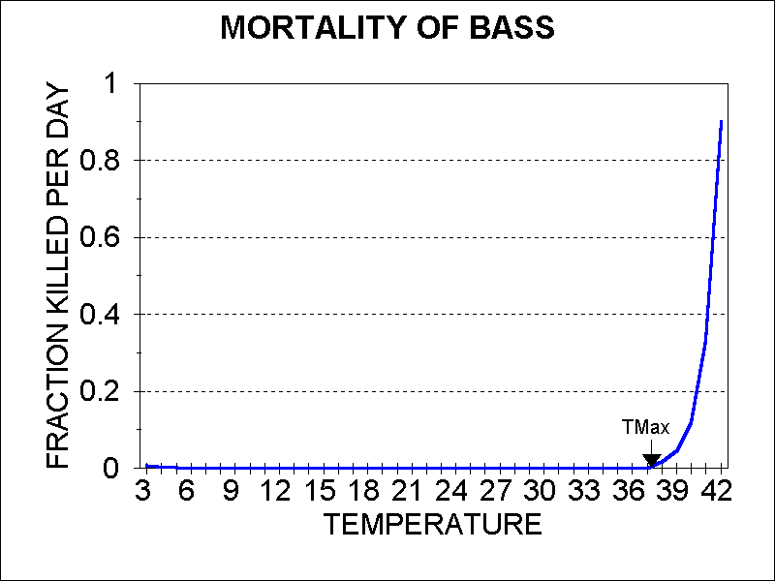

The lower lethal temperature is often 0°C (Leidy and Jenkins, 1976), so it is ignored at this time.

**Stocking and Harvesting of Animals**

Given the importance of anthropogenic impacts to both fish and invertebrate populations within the nearshore marine environment, an interface has been added to allow time-series stocking or removal for all animals. These data may be input in units of g/(m2 day) (stocking or removal) or percent/day (removal).

The result of fish stocking is an increase in the “load” portion of equation **(90)**. The result of fish removal is a decrease in the “load” rate that can become a negative number. The input of “stocked” organisms is assumed to have no organic-chemical burden. Removal of toxicants or nutrients from the system due to fishing or invertebrate removal is tracked with the “fishing loss” mass-balance tracking variables. This procedure ensures the accounting for all mass balances of nutrients and chemicals.

**Suspended Sediment Effects**

The approach used to quantify lethal and sublethal effects of suspended sediments is based on logarithmic models described by Newcombe (for example, Newcombe 2003).

**Summary of Sediment Effects:**

* Mortality
* Reduction in feeding
* Dilution of food by sediment particles
* Stimulation of invertebrate drift
* Loss of spawning and protective habitat in interstices

They take the form of:

 **(115)**

where:

*LethalSS* = cumulative fraction killed by given exposure to a given suspended sediment concentration (fraction/d)

*SlopeSS* = slope for sediment response (unitless)

*SS* = suspended inorganic sediment concentration (mg/L)

*InterceptSS* = intercept for suspended sediment response (unitless)

*SlopeTime =* slope for duration of exposure (unitless)

*TExp* = duration of exposure (d)

Unfortunately, there is a dearth of quantitative data on response to sediments. Therefore, the responses are grouped according to sensitivity, and parameters for surrogate species are used. The user can specify different parameter values; the values given below are provided as defaults.

For sublethal effects, avoidance behavior is noted at SS of about 100 mg/L (Doisy and Rabeni 2004); however, this could only be used as a cue for migration in the model and has been ignored at this time.

Reduction in feeding occurs in game fish due to visual impairment (Crowe and Hay 2004). SS of 25 mg/L seems to be threshold for response (Rowe et al. 2003). The general equation **(115)** is used to represent a decrease in food due to turbidity, but without the exposure factor because the response is instantaneous:

 **(116)**

where:

*HarmSS* = reduction factor for impairment of visual predation (unitless)

*SlopeSS* = slope for suspended sediment response (-0.36, unitless)

*SS* = suspended inorganic sediment concentration (mg/L). If TSS is modeled see **(244)** otherwise, the sum of inorganic sediments in the water column (e.g. *Sand+Silt+Clay*);

*InterceptSS* = intercept for suspended sediment reponse (2.11, unitless)

The equation is parameterized using data for coho salmon with 1-hr exposure (Berry et al. 2003). It was verified with numerous other qualitative observations for salmon, Arctic grayling, and trout (Berry et al. 2003). This equation is used for all visual-feeding fish, especially game fish. The user has the option of turning on this factor

Figure . Reduction in feeding by coho salmon (*Oncorhynchus kisutch*)

due to suspended sediments. Data from (Berry et al. 2003).



For modeling lethal effects, mortality can occur in fish over a range of suspended sediments. Because of the lack of suitable quantitative data, these responses are divided into sensitivity categories specific to this model and differing from Clarke and Wilber (2000) with parameters

for surrogate species that can be considered representative for groups of organisms. The factor also can be turned off for those organisms that are completely insensitive.

***Tolerant***

This category represents those species having a 24-hr LC10 > 5000 mg/L SS. Generally, these are benthic species exposed to the flocculent zone and bottom sediments. The general equation **(115)** is parameterized to accommodate the 24-hr lethality observations and is extended to other times of exposure by fitting to observed 48-hr lethal responses:

** (117)**

where:

*LethalSS* = cumulative fraction killed by given exposure to a given suspended sediment concentration (fraction/d)

*TExp* = time of exposure to given level of suspended sediment (d)

*SS* = minimum suspended inorganic sediment concentration over exposure time (mg/L). If TSS is modeled see **(244)** otherwise, the sum of inorganic sediments in the water column (e.g. *Sand+Silt+Clay*).

The parameters are based on the benthic estuarine fish spot (*Leiostomus xanthurus*), using data compiled in Berry et al. (2003).

Due to lack of data beyond 48 hours, this equation is applied using one- and two-day exposure times only. The maximum effect is chosen from these two equation results.

Figure . Lethality of suspended sediments to spot (*Leiostomus xanthurus*),

a tolerant species, based on data compilation of Berry et al. (2003).



***Sensitive***

This category represents those species having 250 mg/L < 24-hr LC10 <5000 mg/L SS. Small estuarine species seem to be highly sensitive to suspended sediment (Figure 84). The general parameters are based on a composite fit to data for bay anchovy, menhaden, and Atlantic silversides taken from a compilation by Berry et al. (2003). The equation is:

** (118)**

This equation is applied using one- and two-day exposure times along with effects from one, two, and three weeks exposure. The maximum effect is chosen from these multiple calculations.

Figure 80 illustrates the response curve for white perch. The equation exhibits good extension to juvenile rainbow trout with a 28-d exposure to SS (Figure 81) and Chinook salmon with a 1.5-d exposure (Figure 82). In both cases the equation is slightly over-protective, but that is considered appropriate.

Figure . Lethality of suspended sediments to white perch (Morone americana),

a sensitive species, based on data compilation of (Berry et al. 2003).



Figure . Lethality of suspended sediments to juvenile rainbow trout (*Oncorhynchus*

*mykiss*) using parameters for sensitive species. Data from Berry et al. (2003).



Figure . Lethality of suspended sediments to Chinook salmon (*Oncorhynchus*

*tshawytscha*) using parameters for sensitive species. Data from Berry et al. (2003).

***Highly Sensitive***

This category represents those species having a 24-hr LC10 ≤ 250 mg/L SS. Small estuarine species seem to be highly sensitive to suspended sediment (Figure 84). The general parameters are based on a composite fit to data for bay anchovy, menhaden, and Atlantic silversides taken from a compilation by (Berry et al. 2003). The equation is:

** (119)**

This equation is applied using one and two day exposure times along with effects from one two and three weeks exposure. The maximum effect is chosen from these multiple calculations.

Figure . Three-dimensional plot of equation for highly sensitive fish



Although not verified with observed data from longer exposure periods, the equation appears to be robust; it yields reasonable predictions of mortality for a range of SS concentrations and exposure periods.

Figure . Response of bay anchovy to SS. Data from (Berry et al. 2003)



***Sediment Effects on Filter Feeders***

Sediments can clog filter-feeding apparatuses in invertebrates and some fish. A 25% reduction in feeding in *Daphnia* occurs with SS of 6 NTU (~22 mg/L) (Henley, 2000); rotifers are not affected (Rowe et al. 2003). Equation **(116)** can be parameterized to reflect the *Daphnia* response (*SlopeSS* = -0.46 and *InterceptSS* = 2.2, **Figure 85**).

**Figure 85.** Reduction in feeding by Daphnia due to suspended sediments.

Points represent LC75 and supposed LC50, and LC5 values**.**



Increased turbidity can inhibit feeding by mussels; 600 to 750 mg SS/L reduced clearance rates in several mussel species (Henley et al. 2000). This can be used to parameterize Equation **(116)** (*SlopeSS* = -0.47 and *InterceptSS* = 3.1, **Figure 86**).

**Figure 86.** Reduction in clearance of sediment by freshwater mussels due to

suspended sediments. Points represent supposed LC95, LC50, and LC10 values**.**



Reduced pumping was observed at SS > 1000 mg/L in the Eastern oyster (Berry et al. 2003). This too can be used to parameterize Equation **(116)**. (*SlopeSS* = -0.61 and *InterceptSS* = 4.72, **Figure 87**).

**Figure 87.** Reduced pumping in Eastern oysters (*Crassostrea virginica*).

Points represent supposed LC90, LC50, and LC5 values.



A related factor, which is treated separately in the model, is the degree to which there is dilution of food by inorganic particles, offset by selective sorting of particles and feeding (Henley, 2000). *Mytilus edulis*, the blue mussel, and *Crassostrea virginica*, the Eastern oyster, actively sort particles; their food intake should not be affected by SS until very high levels that clog the filter feeding mechanism are reached. In contrast, there is limited selective feeding among many clear-water clams, including the surf clam *Spisula solidissima,* the Iceland scallop *Chlamys islandica*, and probably many of the endangered freshwater mussels (Henley, 2000). The dilution of available food for both filter feeders and grazers decreases as a proportionate function of sediment corrected for the degree to which there is selective feeding (**Figure 88**):

**(120)**

where:

*FoodDilution* = factor to account for dilution of available food by suspended sediment (unitless)

*Food* = preferred food for filter feeders (mg/L) and for grazers (g/m2) (see **(94))**

*Sed* = suspended sediment for filter feeders (mg/L) and deposited sediment for benthic grazers (g/m2)

*Sorting* = degree to which there is selective feeding (unitless)

*Proportion* = proportionality constant, set to 0.01 for snails and grazers and set to 1.0 for all other organisms. (unitless)

To account for the fact that snails and grazers feed on periphyton above the depositional surface, a proportionality constant is utilized for those organisms.

The intermediate variable *Sed* depends on the computation of suspended sediment for filter feeders and the computation of deposited sediment for benthic grazers. If the optional sediment transport submodel (Section 6.1) is used then:

  **(121)**

where:

*Sed* = suspended sediment for filter feeders (taxa = ‘Susp. Feeder’ or ‘Clam’ in units of mg/L or g/m3) and deposited sediment for benthic grazers (taxa = ‘Sed Feeder’ or ‘Snail’ or ‘Grazer’ in units of g/m2);

*ConcSed* = concentration of suspended silt or clay (mg/L) **(224)**;

1000 = conversion factor for kg to g;

*DepositSed* = amount of sediment deposited (kg/m3 day) **(230)**;

*Volume* =water volume, (m3);

*SurfArea* = surface area, (m2); and

*1.0* = days’ accumulation of sediment (day)

If the sediment transport submodel is not used and TSS is used as a driving variable then suspended sediment is computed for filter feeders. Additionally, when TSS is used as a driving variable, deposited sediment (*Sed*) is calculated using the relationship shown in **Figure 91**.

 **(122)**

where:

*Sed* = food dilution equation input **(120)**, (mg/L or g/m2);

*InorgSed* = suspended inorganic sediment computed from TSS (mg/L) (see **(244)**);

*InorgSed60day* = 60 day average of suspended inorganic sediment computed from TSS (mg/L) (see **(244)**)

**Figure 88.** The *FoodDilution* factor as a function of TSS with Food kept constant at 10

mg/L and with Sorting set to 0 and 0.5.



Continued high levels of SS can cause mortality in oysters as shown in **Figure 89**. However, this can be interpreted as the natural consequence of reduced filtration as predicted by parameterization of **(115)**. Therefore, oyster mortality due to SS is not simulated separately.

**Figure 89.** Response of oysters to SS. Data from (Berry et al. 2003).



***Sediment Effects on Grazers***

Sediment reduces preference of New Zealand mud snails and mayflies for periphyton (Suren 2005), which is ignored by the model. More important, the food quality of periphyton declines linearly with increasing fine sediment content (Broekhuizen et al. 2001). This is represented as food dilution by **(120)**.

Riffle areas are degraded or lost by deposition of fine sediment, including sand (Crowe and Hay 2004). A 12-17% increase in fines in riffles areas resulted in 27-55% decrease in mayfly abundance; this did not affect chironomids and simulids, and riffle beetles actually increased (Crowe and Hay 2004). Drift rates doubled from 2.3%/d to 5.2%/d with a 16% increase in fine interstitial sediments; chironomids and caddisflies were affected (Suren and Jowett 2001). This is represented by a function in which the deposition rate is compared to a trigger value beyond which there is accelerated drift:

 **(123)**

where:

*Drift* = loss of zoobenthos due to downstream drift (g/m3⋅d); and

*Dislodge* = fraction of biomass subject to drift per day (unitless).

Nocturnal drift is a natural phenomenon:

 **(124)**

where:

*AvgDrift* = fraction of biomass subject to normal drift per day (unitless).

 **(125)**

where:

*AccelDrift* = factor for increasing invertebrate drift due to sediment deposition (unitless);

*Deposit* = total rate of inorganic sediment deposition (kg/m2 day), **(125b)**;

*Trigger* = deposition rate at which drift is accelerated (kg/m2 day).

**Figure 90.** AccelDrift as a function of depth-corrected

sediment deposition with Trigger = 0.2**.**



The model computes daily sediment deposition rate based on suspended sediment using the following relationship:

 **(125b)**

where:

*Deposit* = total rate of inorganic sediment deposition (kg/m2 day), **(125b)**;

*SS* = suspended inorganic sediment concentration (mg/L). If TSS is modeled see **(244)** otherwise, the sum of inorganic sediments in the water column (i.e. *Sand+Silt+Clay*);

**Figure 91.** Relationship of one-day sedimentation   
to average TSS; data from Larkin and Slaney (1996)..



Ephemeroptera, Pteroptera, and Trichoptera (mayfly, stonefly, and caddisfly , or EPT) diversity declines when the fines (<0.25 mm) exceed 0.8% (Kaller and Hartman 2004). This change in composition should result from proper parameterization of Equation **(125)**.

***Interstitial Sediments***

Salmonid reproduction is adversely affected by deposition of fines, with 27% fines being a threshold (Nelson and Platts, unpublished report, cited by Rowe et al. 2003). “Multiple age classes of both salmonids and sculpins were uncommon where average instream surface fines were greater than 30%, and nearly absent above 40%” (Rowe et al. 2003). Both the eggs and the yolk-fry or alevins are sensitive to sedimentation of fines, including sand. Sedimentation in spawning gravels can be related to average suspended sediment (TSS) concentrations (Larkin and Slaney 1996). The relationship is logarithmic for average TSS over a 60-day period (Figure 92).

Figure 92. Relationship of 60-day sedimentation to average TSS;  
data from (Larkin and Slaney 1996).



A similar measure of fines is embeddedness, which is the extent to which sand, silt, and clay fill the interstitial spaces among gravel and cobbles (Osmond et al. 1995). Good spawning substrate is characterized as less than 25% embedded (Flosi et al. 1998). The data that allow us to predict percent fines also yield an estimate of percent embeddedness (Figure 93), and that relationship is used in the model. Although the training data only go to 34% embeddedness, the log relationship using averaged data allows the regression to extend to any reasonable level of suspended sediment. The user can enter an observed “baseline embeddedness” in the site record, and that can be used as an initial condition. A corresponding embeddedness threshold value can be entered in the animal record. If that value is exceeded then exclusion can be assumed (mortality = 100%). Although this functionality is intended for salmonids, it can also apply to other fish such as sculpins and to invertebrates that hide in the interstices. In practice, the maximum 60-day moving average of suspended sediments is used to compute the percent embeddedness; if the initial percent embeddedness is exceeded then the new simulated percent embeddedness is used. The possibility of scour from a high-discharge event resetting the percent embeddedness is ignored.

Figure 93. Relationship of 60-day percent embeddedness to average TSS;  
 data from (Larkin and Slaney 1996).



**Gamete Loss and Recruitment**

Eggs and sperm can be a significant fraction of adult biomass; in bluegills these can be 13 percent and 5 percent, respectively (Toetz, 1967), giving an average of 9 percent if the proportion of sexes is equal. Because only a small fraction of these gametes results in viable young when shed at the time of spawning, the remaining fraction is lost to detritus in the model.

There are two options for determining the date or dates on which spawning will take place. A user can specify up to three dates on which spawning will take place. Alternatively, one may use a construct that was modified from a formulation by Kitchell et al. (1974). As a simplification, rather than requiring species-specific spawning temperatures, it assumes that spawning occurs when the temperature first enters the range from six tenths of the optimum temperature to 1° less than the optimal temperature. This is based on a comparison of the optimal temperatures with the species-specific spawning temperatures reported by Kitchell et al. (1974). Depending on the range of temperatures, this simplifying assumption usually will result in one or two spawnings per year in a temperate ecosystem when a simple sinusoidal temperature function is used. However, the user also can specify a maximum number of spawnings.

The loss rate for gametes is estimated for both fish and invertebrates as a function of user-specified intrinsic gamete mortality and increased mortality due to effects of organic toxicants, low oxygen, and salinity on adults (*FracAdults* being a function of carrying capacity).

 **(126)**

where:

*Temperature* = ambient water temperature (°C);

*TOpt* = optimum temperature (°C);

*GameteLoss* = loss rate for gametes (g/m3⋅d);

*GMort* = gamete mortality (1/d);

*IncrMort* = increased gamete and embryo mortality due to toxicant (see **(426)**, 1/d);

*O2EffectFrac* = calculated fraction of gametes lost at a given oxygen concentration and exposure time (1/d), see **(205);**

*PctGamete* = fraction of adult predator biomass that is in gametes (unitless); and

*FracAdults* = fraction of biomass that is adult (unitless);

*SaltMort* = effect of salinity on gamete loss rate (unitless), see **(440)**; and

*Biomass* = biomass of predator (g/m3).

As the biomass of a population reaches its carrying capacity, reproduction is usually reduced due to stress; this results in a population that is primarily adults. Therefore, the proportion of adults and the fraction of biomass in gametes are assumed to be at a maximum when the biomass is at the carrying capacity (Figure 94):

Figure . Correction for population-age structure

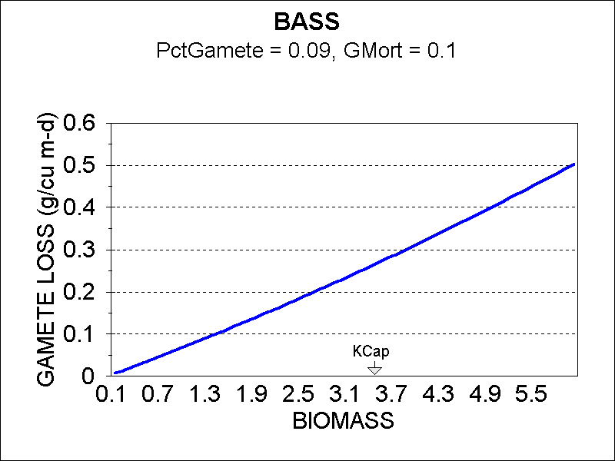

 **(127)**

where:

*KCap* = carrying capacity, the maximum sustainable biomass (g/m2);

*ZMean* = mean depth from site underyling data (m).

Spawning in large fish results in an increase in the biomass of small fish if both small and large size classes are of the same species. Gametes are lost from the large fish, and the small fish gain the viable gametes through recruitment:

 **(128)**

where:

*Recruit* = biomass gained from successful spawning (g/m3⋅d).

**Washout and Drift**

Downstream transport is an important loss term for invertebrates. Zooplankton are subject to transport downstream similar to phytoplankton:

 **(129)**

where:

*Washout* = loss of zooplankton due to downstream transport (g/m3⋅d);

*Discharge* = discharge (m3/d), see Table 3;

*Volume* = volume of site (m3), see **(2)**; and

*Biomass* = biomass of invertebrate (g/m3).

Likewise, zoobenthos exhibit drift, which is detachment followed by washout, and it is represented by a construct that is original with AQUATOX:

 **(130)**

where:

*Drift* = loss of zoobenthos due to downstream drift (g/m3⋅d); and

*Dislodge* = fraction of biomass subject to drift per day (unitless), see **(131)** and **(132)**.

Nocturnal drift is a natural phenomenon:

 **(131)**

where:

*AvgDrift* = fraction of biomass subject to normal drift per day (unitless).

Animals also are subject to entrainment and downstream transport in flood waters. In fact, annual variations in fish populations in streams are due largely to variations in flow, with almost 100% loss during large floods in Shenandoah National Park (NPS, 1997). A simple exponential loss function was developed for AQUATOX:

 **(132)**

where:

*Entrainment* = entrainment and downstream transport (g/m3∙d);

*Biomass* = biomass of given animal (g/m3);

*MaxRate* = maximum loss per day (1/d);

*Vel* = velocity of water (cm/s), **(14)**;

*VelMax* = velocity at which there is total loss of biomass (cm/s); and

*Gradual* = slope of exponential, set to 25 (cm/s).

Figure . Entrainment of animals as a function of stream velocity

with *VelMax* of 400 cm/s

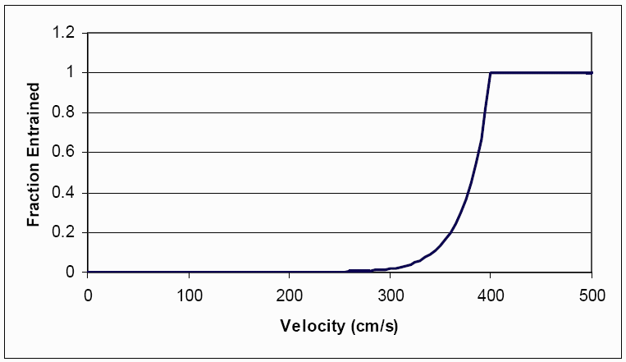

Entrainment is not applied to pelagic invertebrates as these organisms already passively wash out of a system during a flood event **(129)**.

**Migration and Anadromous Models**

Within the HMS model, migration patterns are assumed to take place within the HMS workflow rather than within a multi-segment AQUATOX model itself. Migration logic and Anadromous logic have not been included within HMS AQUATOX. These sections are omitted from the technical documentation for that reason.

**Promotion** **and Emergence**

Although AQUATOX is an ecosystem model, promotion to the next size class is important in representing the emergence of aquatic insects, and therefore loss of biomass from the system, and in predicting bioaccumulation of hydrophobic organic compounds in larger fish. The model assumes that promotion is determined by the rate of growth. Growth is considered to be the sum of consumption and the loss terms other than mortality and migration; a fraction of the growth goes into promotion to the next size class (cf. Park et al., 1980):

 **(136)**

where:

*Promotion* = rate of promotion to the next size class or insect emergence **(137)** (g/m3⋅d);

*KPro* = fraction of growth that goes to promotion or emergence (0.5, unitless);

*Consumption* = rate of consumption (g/m3⋅d), see **(98)**;

*Defecation* = rate of defecation (g/m3⋅d), see **(97)**;

*Respiration* = rate of respiration (g/m3⋅d), see **(100)**;

*Excretion* = rate of excretion (g/m3⋅d), see **(111)**; and

*GameteLoss* = loss rate for gametes (g/m3⋅d), see **(126)**.

This is a simplification of a complex response that depends on the mean weight of the individuals. However, simulation of mean weight would require modeling both biomass and numbers of individuals (Park et al., 1979, 1980), and that is beyond the scope of this model at present. Promotion of multi-age fish is straightforward; each age class is promoted to the next age class on the first spawning date each year. The oldest age class merely increments biomass from the previous age class to any remaining biomass in the class. Of course, any associated toxicant is transferred to the next class as well. Recruitment to the youngest age class is the fraction of gametes that are not subject to mortality at spawning. Note that the user specifies the age at which spawning begins on the “multi-age fish” screen.

Insect emergence can be an important factor in the dynamics of an aquatic ecosystem. Often there is synchrony in the emergence; in AQUATOX this is assumed to be cued to temperature with additional forcing as twice the promotion that would ordinarily be computed, and is represented by:

 **(137)**

where:

*EmergeInsect* = insect emergence (mg/L⋅d);

*Temperature* = ambient water temperature (°C); and

*TOpt* = optimum temperature (°C);

Because emergence is a function of the organism’s growth rate, if the temperature passes through the optimal temperature interval while the growth rate of the organism is zero or below zero, emergence of insects does not occur.

**Size Classes for Crabs**

The capability to model fish with size classes (juvenile and adult) has been part of AQUATOX nearly since the model’s creation. However, this capability had not been extended to invertebrates. Size classes have now been added to the AQUATOX model to better reflect the differences in life history for some predatory invertebrates (crabs in particular). This change allows the model to represent differential bioenergetics within life stages, and the different vulnerability of these organisms to predation pressures and organic toxicants.

No modifications were made to the fish size-class model described here. However, the model’s interface now includes two small predatory invertebrate compartments that may be linked to the larger predatory invertebrate categories.

**4.4 Oysters**

New to AQUATOX Release 3.2 is a size-class model for oysters, containing four specified life stages for oysters (Figure 96).

Figure . Schematic of AQUATOX Oyster Size-Class Model



Oysters are modeled using the same differential equations that govern all animals within AQUATOX; clams and other bivalves have always been included in the model. Oysters are unique in AQUATOX, however, due to their life-history classifications and the promotion and recruitment of biomass from one biotic compartment to the next.

Oyster veligers are assumed to be suspended in the water column and are modeled with mg/L units. Oyster veligers can be modeled alone in non-oyster-reef habitats. If seed oysters or sack oysters are included then it is assumed that an oyster reef is specifically being modeled. Rules for promotion and recruitment between size classes follow.

* Veliger promotion to Spat
  + If salinity is sufficient (between 5 and 30 ppt) then it is assumed that veliger successfully settles over its 3-week life span. Cake (1983) cites multiple sources (Carriker 1951, Davis 1958, Calabrese & Davis 1970) who indicate veligers will settle at salinities 5-30 ppt.)
  + 5% of biomass is assumed to settle each day and is assumed “competent” spat. This rate is estimated using a 20-day settlement period consistent with the veliger life span cited in Galtsoff (1964) cited in Cake (1983) and Bahr and Lanier (1981) cited in VanderKooy (2012).
* Spat promotion to Seed
  + Spat are generally parameterized with high mortality rates, including predation. VanderKooy (2012) cites several papers which collectively estimate spat to seed mortality to range from 15-100%.
  + 50% of biomass growth is assigned to the seed category. This is the same promotion algorithm that has historically been used for fish size-class promotion in AQUATOX **(136).**
  + This promotion assumption is a simplification of a complex response that depends on the mean weight of the individuals. However, simulation of mean weight would require modeling both biomass and numbers of individuals (Park et al., 1979, 1980) which is presently beyond the scope of this model.
* Seed promotion to Sack oyster
  + Like spat promotion, 50% of biomass growth is assigned to the sack category.
* Sack spawning to Veliger (recruitment)
  + As a simplifying assumption, Sack are the exclusive contributors to overall spawned biomass. Menzel (1951) is cited in VanderKooy (2012), indicating that oysters in the Gulf can become sexually mature within 4 weeks of settlement (i.e. Seed can also contribute to recruitment). However, VanderKooy (2012) states that “the number of gametes released during each spawn is directly correlated with oyster size and gonadal development (Davis and Chanley 1955, Galtsoff 1964, Thompson et al. 1996) For this reason, it is assumed that Sack are the dominant contributors.
  + Spawning is triggered when salinity is greater than 10 ppt and temperature is greater than 20 degrees C. VanderKooy (2012) claim that “salinity fluctuations do not appear to play a significant role in controlling spawning in oysters, however, salinities below 5-6 ppt can inhibit gametogenesis (Butler 1949, Loosanoff 1953).” However, there is support for the 10 ppt threshold in Cake (1983), who claims “optimal spawning salinity ranges from 10 to 30 parts per thousand (ppt).”
  + With regards to temperature, Cake (1983) cites multiple sources (Ingle 1951, Menzel 1955, Hayes and Menzel 1981) who indicate mass spawnings typically occur when temperatures reach and/or exceed 25 degrees C. However, there is ample support for the 20 degree C threshold, as VanderKooy (2012) cites multiple authors (Butler 1949, Loosanoff 1953, Schlesselman 1955, Hofstetter 1977, 1983) who indicate the threshold is indeed 20 degrees C.
  + The “percent gamete” parameter determines the extent of biomass expelled. This is spread over 275 days of spawning, based on Gulf-of-Mexico data. Cake (1983) cites (Butler 1954), who claims that spawning generally occurs year-round in the Gulf of Mexico, but does not occur during the three-month span from December to February. A site-specific number of spawning days may be specified for other locations.
  + The *Gamete loss* equation **(126)** splits spawning between viable veliger biomass and non-viable organic matter (detritus).

**Lethal Effects due to Low Oxygen**

AQUATOX represents both lethal and non-lethal effects from low concentrations of dissolved oxygen. The US EPA saltwater criteria document suggests the following general model for estimating time to mortality based on data from two species of saltwater juvenile fish, one species of juvenile freshwater fish, and three species of saltwater larval crustaceans (U.S. Environmental Protection Agency, 2000, Equation 9):

 **(199)**

where:

*LCTime* = Lethal Concentration for a given percentage of a population over the given duration (mg/L);

 **(200)**

and

 **(201)**

To produce a general model of low oxygen effects, concentrations at which different percentages are killed (holding duration constant) also need to be related to one another. That is to say, a model that relates LC5 to LC50 to LC95 must be produced. Examining available data (Figure 119 to Figure 121), a linear model seems appropriate

 **(202)**

where:

*LCFracduration* = concentration at which given percentage of organisms are killed estimated from a known lethal concentration (holding duration constant).

*LCKnownduration* = known lethal concentration for a given percentage of organisms at the given duration.

Further examination of available data indicates different slopes for different species (Figure 122). Most important, however, is that for all species, the range of slopes is quite narrow, ranging from ‑0.001 to ‑0.01. This indicates that for all species and all durations, the range at which mortality occurs due to insufficient oxygen is quite narrow. For this reason, the intermediate value of ‑0.007 was chosen as it is likely to reproduce available data reasonably well. This is preferable to having a user input this slope as these data are unlikely to be available to most users. Given a known lethal concentration at a known duration and using this slope, the Intercept can be calculated see (204).

Figure 119. Menhaden percent killed vs. O2 exposure concentration



Figure 120. Blue Crab percent killed vs. O2 exposure concentration



Figure 121. Spot percent killed vs. O2 exposure concentration



Figure 122. Slope vs. species type



Combining equations **(199)** to **(202)**, given a user input 24-hour lethal concentration (in the “Animal underlying data” screen), the model can calculate the fraction killed at a given duration and at a given concentration.

 **(203)**

where:

 **(204)**

and:

*PctKilled* = estimated percent killed at a given oxygen concentration and exposure time;

*O2Conc*= concentration of oxygen (mg/L);

*ExpTime* =exposure time (hours);

*LCKnown­duration* = user input lethal concentration (24-hour) (mg/L);

*PctKilledKnown* = user input percentage for lethal concentration (percentage);

The model presented in equation **(203)** requires a user to input 24-hour lethal concentration as this is the basis for the general model presented in the saltwater criteria document. If a user has a lethal concentration at a different duration, the user must estimate the 24-hour lethal concentration, bearing in mind that the relationship between exposure time and lethal concentrations is usually logarithmic in nature (Figure 123). There are insufficient data to develop a general model that will estimate 24-hour lethal concentrations given different user input durations.

AQUATOX tracks oxygen concentrations over the previous 96 hours from the current time-step. The oxygen effects model is then applied with the durations shown below:

* 1 hour, 4 hours, 12 hours *(when model is run with hourly time-step only)*
* 1 day, 2 days, 4 days *(relevant to both hourly and daily time-steps)*

AQUATOX finds the minimum oxygen concentration over each of these time-periods and applies it to equation **(203)**. The maximum percent killed over all of the durations tested is then applied to the animal biomass by increasing mortality (equations **(90)** and **(112)**) .

Figure 124 shows an example of a three-dimensional response surface produced by this model. This is a model of low oxygen lethality for Atlantic menhaden produced by entering a 24-hour LC95 of 0.61 mg/L. Figure 125 shows model predictions using a 24 hour LC50 of 3 mg/L overlaid on a figure from the U.S. Environmental Protection Agency’s 1986 *Quality Criteria for Water.* This plot shows that the default value of 3 mg/L works well for many species, but for white bass, for example, the LC50 should be set to a lower concentration.

Figure 123. LC50 to exposure time based on data from U.S. EPA 2000



Figure 124. Example of low O2 lethality model- menhaden response surface



(Exposure Time in Hours)

Figure 125. 96-hour model predictions (in red) compared against continuous exposure data   
(Data from U.S. EPA 1986, model set up using a 24-hour LC50 of 3.0mg/L)



**Non-Lethal Effects due to Low Oxygen**

The same three dimensional model used for lethal effects is utilized to calculate non-lethal low oxygen effects (functions of exposure level and time.) In this case, *EC50 reproduction* affects the fraction of gametes that are lost and *EC50 growth* affects consumption rates.

 **(205)**

and:

 **(206)**

where:

*O2EffectFrac* = calculated fraction of gametes lost or reduction in growth rate at a given oxygen concentration and exposure time;

*O2Conc*= concentration of oxygen (mg/L);

*ExpTime* =exposure time (hours);

*EC50duration* = user input 50% effect concentration (24-hour) (mg/L);

O2EffectFrac is then applied to ingestion (91) and gamete loss (126).